***Experiment 3***

**Aim:** Code Documentation Practice: Write and document Python functions and classes using docstrings and generate HTML documentation using tools like Sphinx or MkDocs.

**1. Sphinx Documentation:** Created structured, dynamic documentation with Sphinx, generating HTML from re-Structured Text for enhanced project documentation.

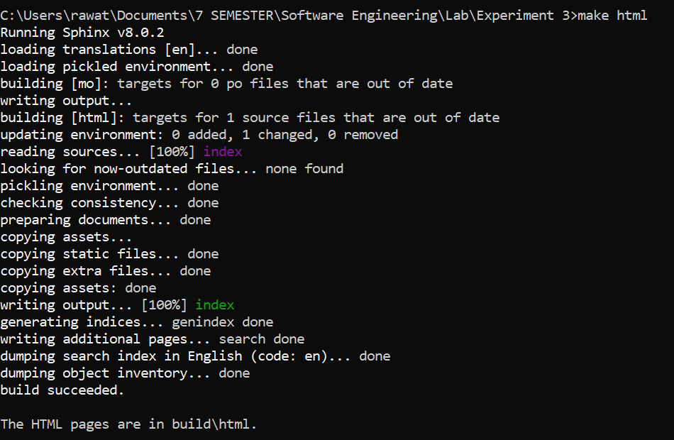

***Fig 1: Running Sphinx Commands***

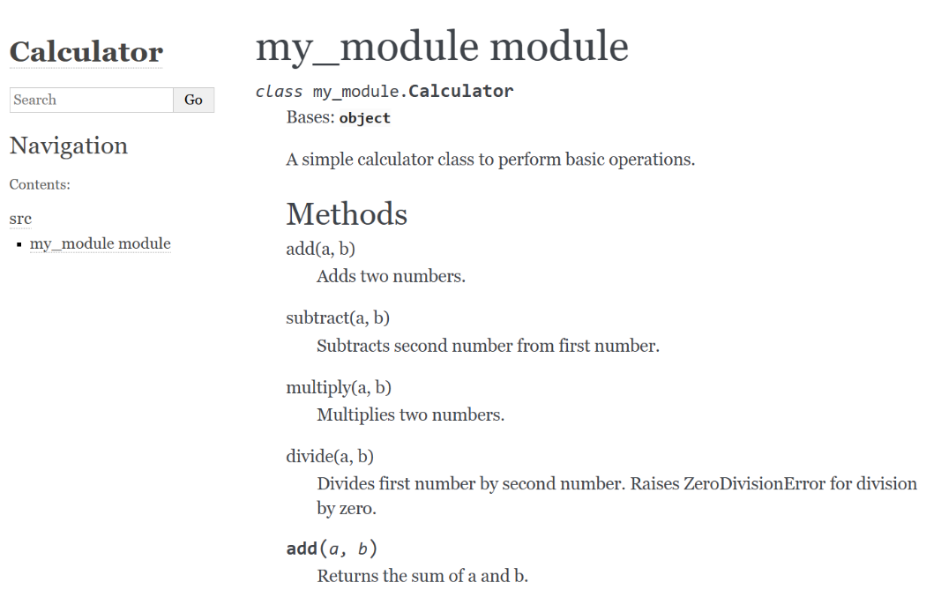

***Fig 2: Output Sphinx Documentation***

**2. Mkdocs Documentation:** Set up a simple documentation site with Markdown using MkDocs, utilizing the Material theme for a streamlined and responsive design.

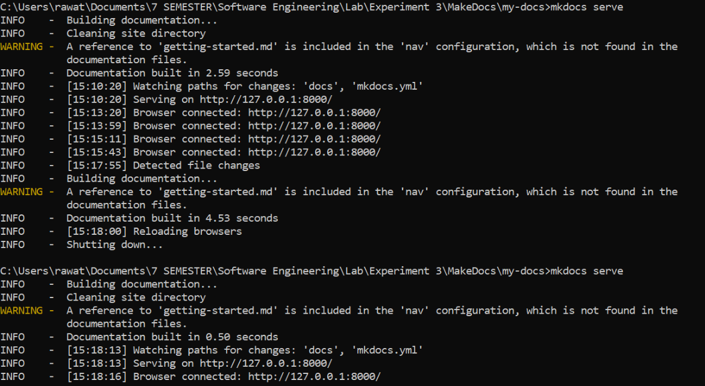

***Fig 1: Running Mkdocs Commands***

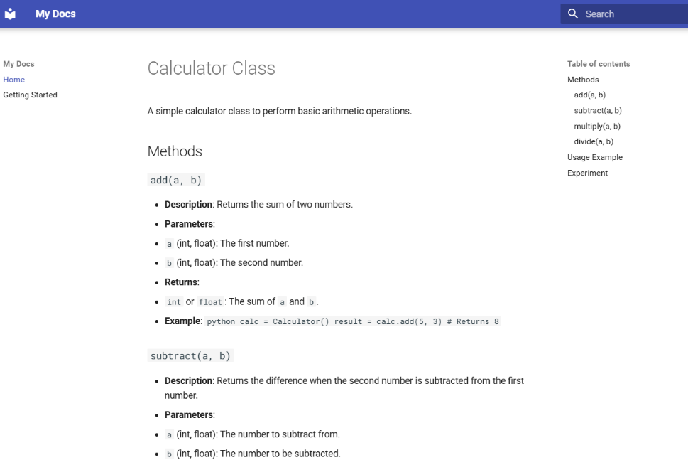

***Fig 2: Output MkDocs Documentation***